**Assignment no. 11**

**Build scaling plans in AWS that balances load on different EC2 instances**

**Visit** **aws.amazon.com** **and Sign in.Go to EC2 dashboard and click “Launch Template”**

**Click on “Create launch instance” option**

**1.….**.

**2.**

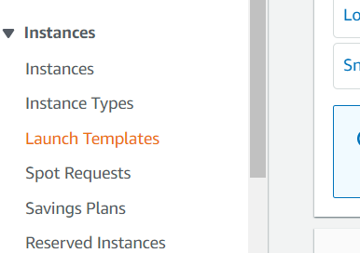

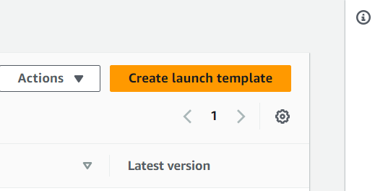

**Give template name,template version description and select autoscaling guidance**

**Select Ubuntu as AMI**

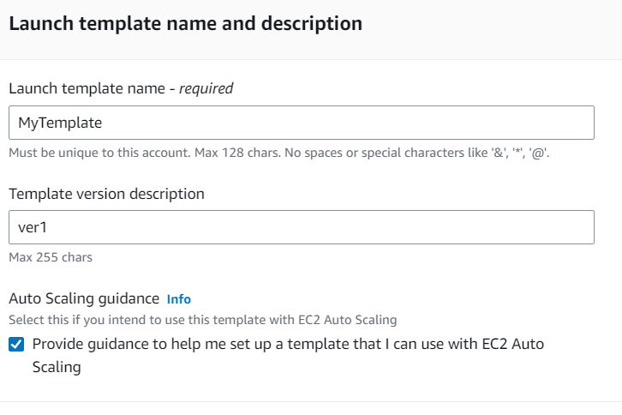

**s**

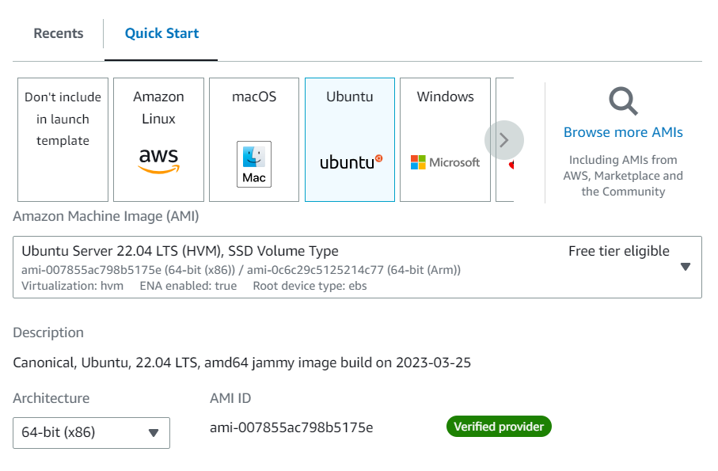

**3.**

**4.….**.

**Select “t2.micro” as instance type and key pair for login**

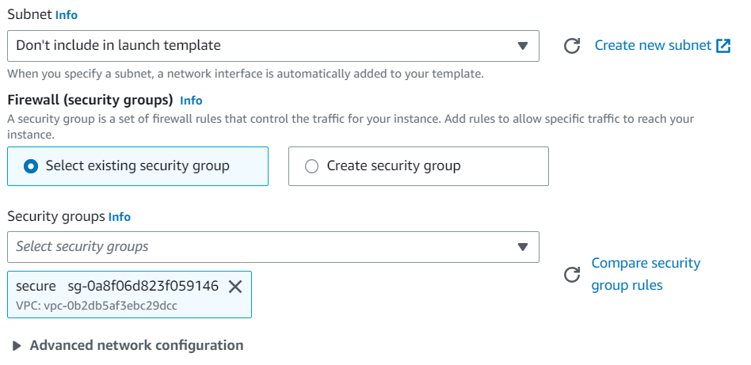

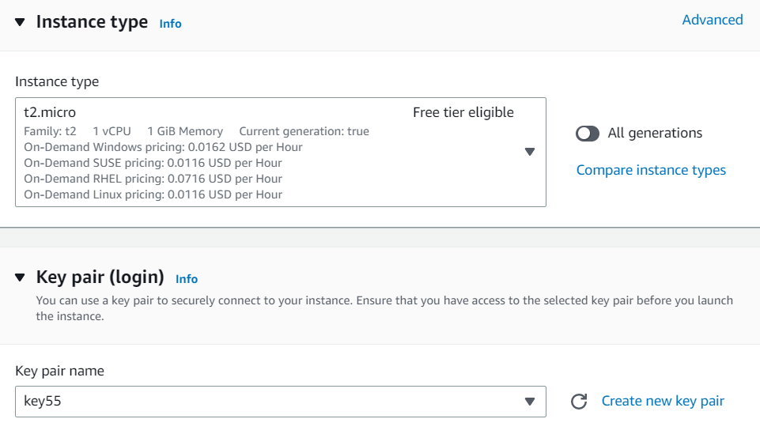

**Now select the existing security group which you created for the project**

**5.….**.

**6.**

**In the EC2 dashboard click on “Auto scaling groups and then click on create Auto Scaling groups”**

**Type the following user data and click on create launch template**

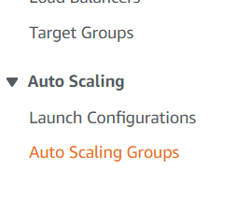



**7.….**.

**8.**

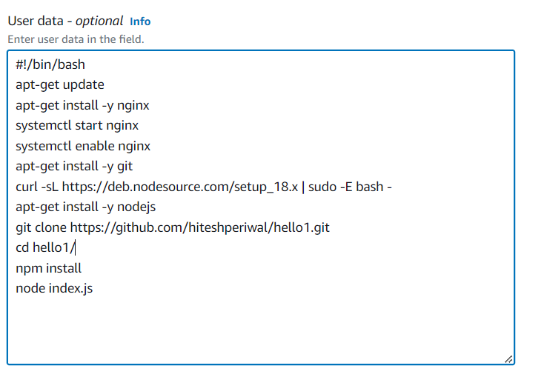

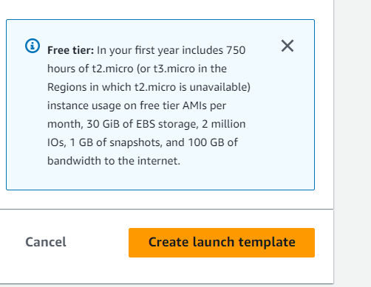

**Enter the Auto Scaling group name.Select the template created by you and its version as latest.Click on “Next”**

**Select all the Availability zones and subnets and click on “Next”**

**10.**

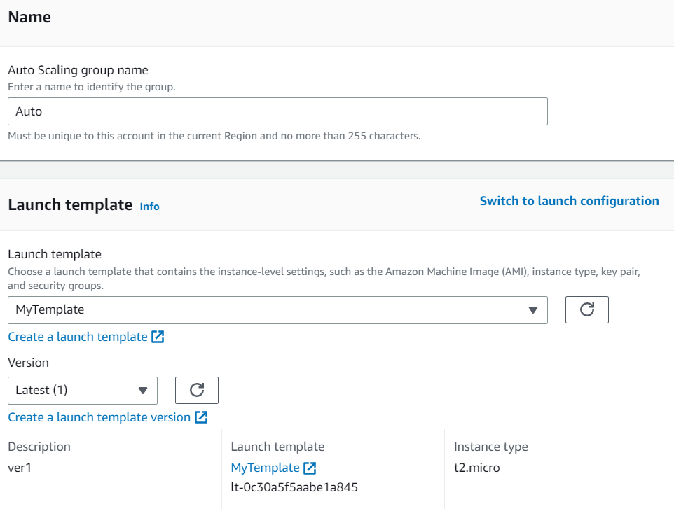

**S**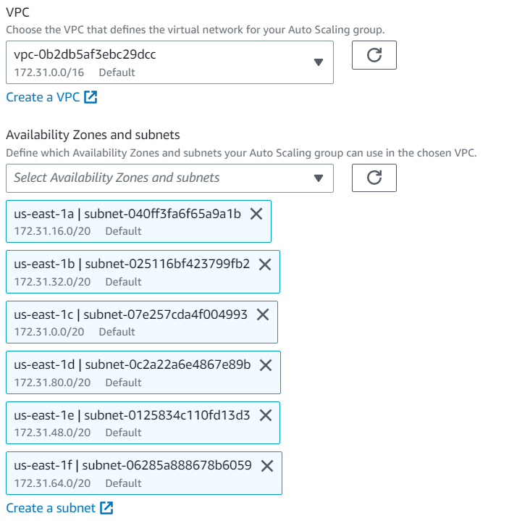

**9.**

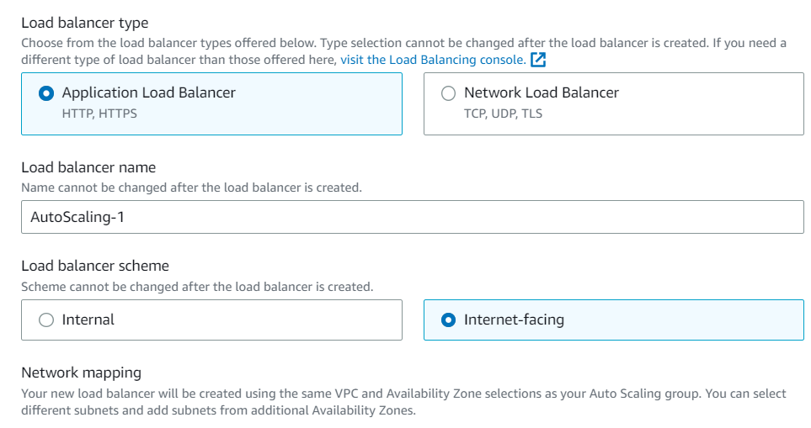

**In the listeners section, enter the port as mentioned in your project and health check grace period as 300 seconds.**

**In the load balancing ,select “Attach to a new load balancer”.In the load balancer type select “Application load balancer”.Give the load balancer name and select the load balancer scheme as internet facing**

**12.**



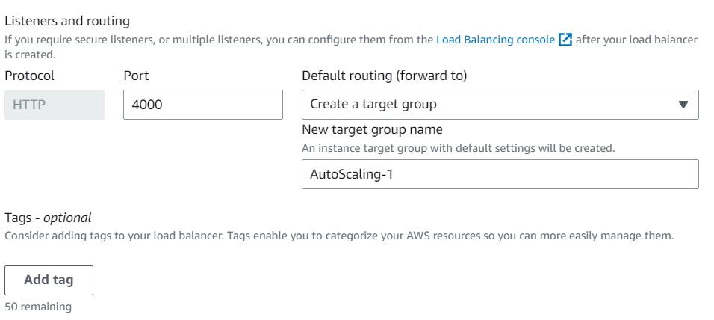

**11.**

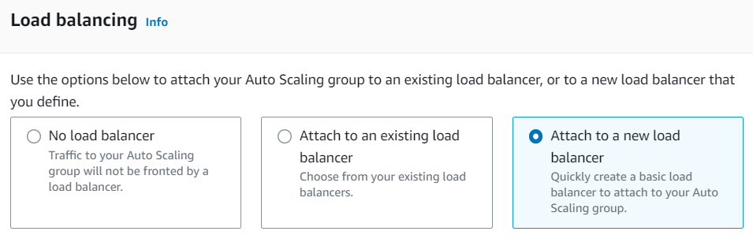

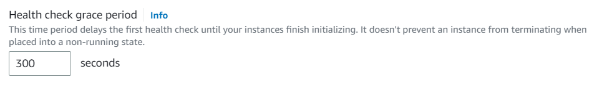

**13.**

**S**

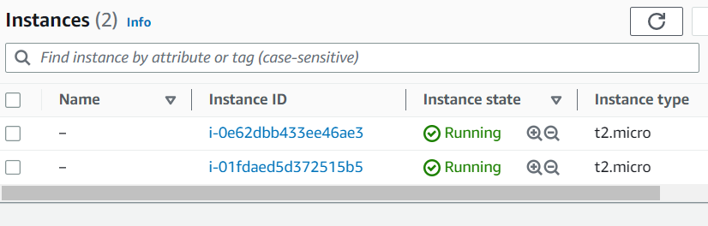

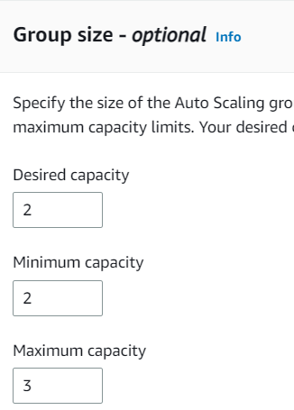 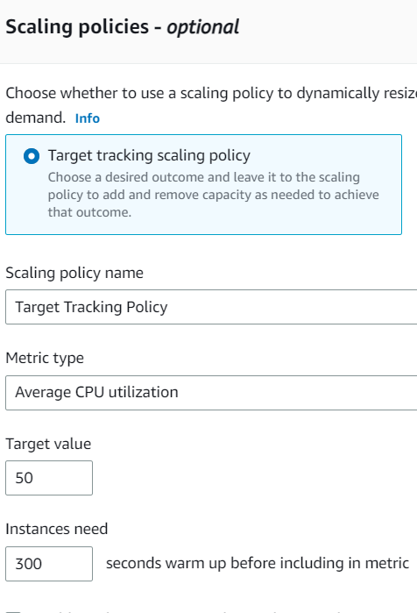

**Now two instances are running.Overload one of them to see whether auto scaling functionality is working or not.**

**Enter the desired capacity as 2,minimum capacity as 2 and maximum capacity as 3.Select target tracking scaling policy,give it a name,target value 50 and 300 seconds as warm up .Click on “Next”,”Next”,”Next” and then “Create auto scaling group”.**

**14.**

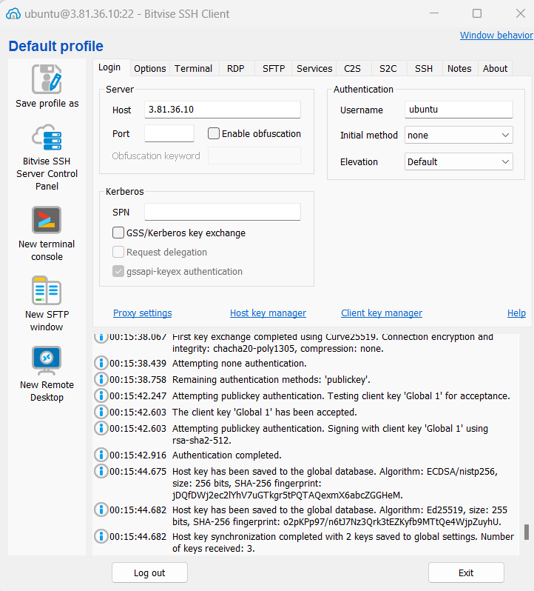

**Open the terminal console,create a shell executables file,type the following commands and execute the file to overload the server**

**16.**

**Login in Bitwise SSH client using one of the public ip address of the instances created and the key pair used in those instance.**



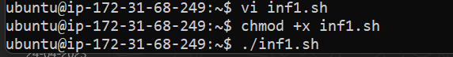

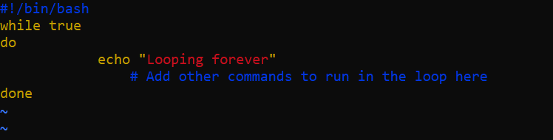



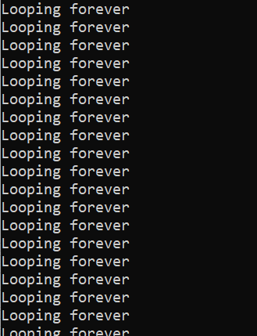

**15.**

**S**

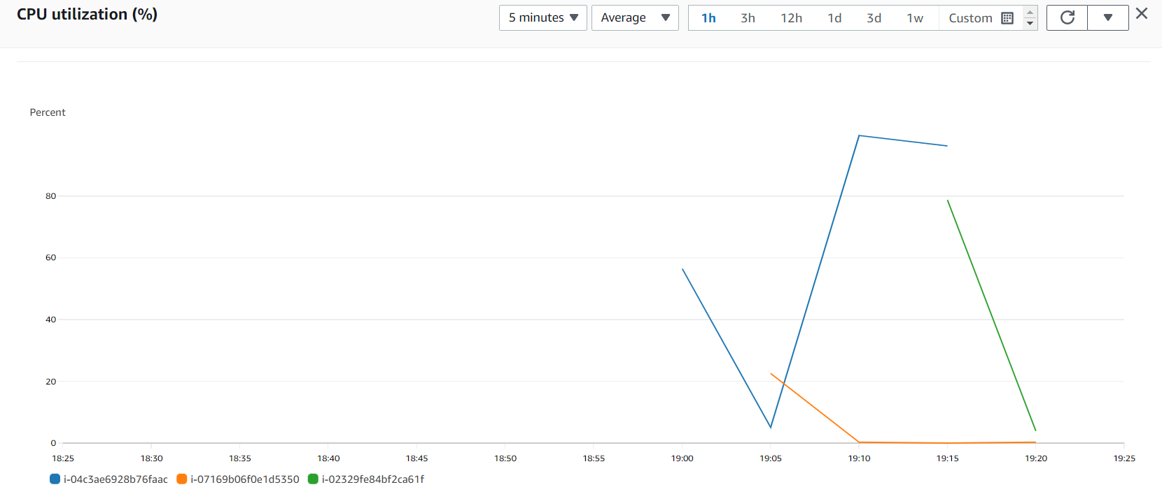

**Select the running instances and click on monitoring.You will observe creation of new instance during the 300 seconds warm up when the server is overloaded.Hence load is balanced on different EC2 instances**

**17.**